Exercise:
Plotting Education Data

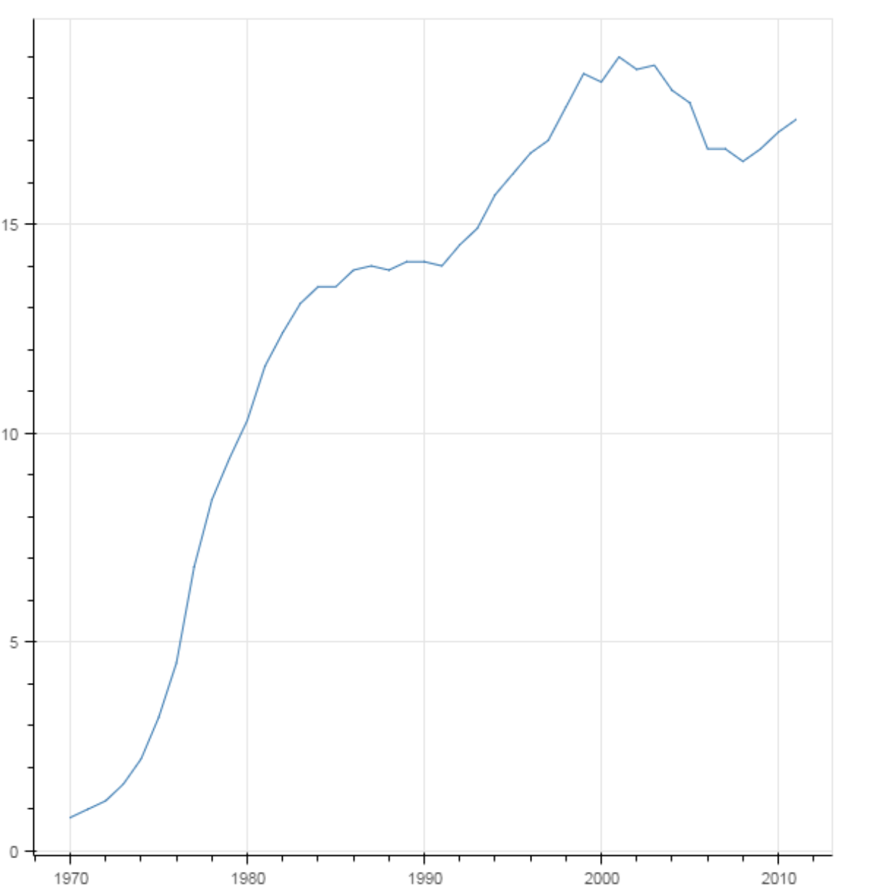
The following line graph shows the percentage of women who have received a bachelor's degree over the years in the USA. The graph was produced from the Year and Engineering columns of the CSV file provided in the following link:
https://pythonizing.github.io/data/bachelors.csv
Try to reproduce the graph using Bokeh.

